**REPORT**

**Project Name- ONLINE MANDI**

**Team Name- G5**



by

* **Abhishek Rai (Back-end Developer)**
* **Anshumaan Singh Hada (Front-end Developer)**
* **Riya Bobde (Co-developer)**
* **Priyal Hedau (Team and project manager)**
* **Vedika Shivhare (Project Representor)**

**ABSTRACT**

Many research article is planned to know scope of online shopping of agricultural inputs in rural India and totrace the opportunities and challenges for online shoppers to tape the rural agriculture market in India. In today’s agriculture and the product supply chain in general, there appears a history of quick adoption and assimilation of new technologies, especially cost reduction technologies. Farming is identified as one of the great promises of e-commerce due to the high level of fragmentation present in the supply chain, large volumes traded, and homogeneous products only reinforced the expectations. Farming is an emerging field focusing on the enhancement of agricultural and rural development through improved information and communication processes. This involves the conceptualization, design, development, evaluation and application of inovative ways to use information and communication technologies in the rural domain, with a primary focus on agriculture.

The technologies promises to revolutionize the landscape of agricultural business. Already E-commerce is clearly beginning to have a major impact in the farming sector. The way people go about purchasing agricultural products is of great concern. Sometimes buyers have to travel far distances to get agricultural products and getting the right quality is not guaranteed. Also, various market prices cannot be compared because buyers do not have all the time and resources to visit every agricultural farm. Hence, the need for an website is important, which would help farmers and other buyers, make their appropriate business transactions online. So an e-commerce website is developed using web service technologies as the communication infrastructure between the buyers and the farmers is possible. This paper focuses on how mobile agents, a new technology can be incorporated into an Agriculture E-commerce system to aid buying and selling in the agricultural sector and more importantly, how prices can be retrieved from Agricultural electronic commerce sites in cases where the buying agent recommends the best price.

**Table of Contents**

|  |  |
| --- | --- |
| **Contents** | **Page No.** |
| Abstract | i |
| Table of Contents | ii |

|  |  |  |
| --- | --- | --- |
| **Chapter 1:** | **Introduction** |  |
| **Chapter 2:** | **Objectives** |  |
| **Chapter 3:** | **System Design** |  |
| **Chapter 4:** | **System Implementation** |  |
| **Chapter 5:** | **Applications** |  |
| **Chapter 6:** | **Conclusion and Future Scope** |  |
|  | **References** |  |

**CHAPTER 1: Introduction**

We have Built a website which would help the farmers for buying and selling of goods and services . The project deals with respect to the farmers benefit of getting their products sale at a best price online. This project implementation is done with Hypertext Markup Language (HTML), Cascading Style Sheets(CSS) and Javascript and launched with the help of firebase. It includes the main file and readme file for the code and description respectively. Thus, it create a platform for Farmers where they can get every possible items related to farming.

The e-commerce website project help farmers ensure greater profitability through direct farmer to end user communication. Here, the main users of this website are farmer, customer, and admin. Farmers will get unique interface where they can perform marketing, get the correct rates of the market, get in touch with SMS or Email and gather knowledge of different schemes and get pay online. Agricultural E-commerce enables good trading possibilities by supporting different business models such as multi-suppliers, e-sales and several types of auctions. This will help farmers trained and informed in the management of natural resources and production of agricultural commodities. Agriculture plays a vital role in addressing these challenges and uplifting the livelihood of Indian farmers. Today E-commerce lacks fully buying and selling goods and still requires a significant manual effort by users. So, our project tries to solve all the problems which are faced by the farmers during farming.

**CHAPTER 5: Applications**

As we have all know the use of the Internet is essential for E-commerce. The Internet as a global network, however, implies the use of different services, the most popular of which is the World Wide Web, or just the Web. The Web is a way to access information through the Internet. It is a model for information exchange that uses the HTTP protocol as one of the languages used for data transfer within the network. Web services that use the HTTP protocol to exchange business logic use the Web to exchange and share information. In order to browse the web effectively, it is necessary to use search engines, such as Google Chrome, Internet Explorer, Mozilla Firefox and others. Without search engines it is not possible to access Web contents, which can vary from text, images and sounds, to videos.

1. **Websites that provide transaction cost savings**

Transactions, in this context, include the flow of information, goods and

money. Such transactions are significant different than conventional,

since in traditional trade goods can be seen (touched), contracts between

stakeholders (a quote, dispatch note, receipt, invoice) are in a form of a

hard copy and payments are in cash or cashless.

When it comes to e-commerce, all information, money, and sometimes

even goods must be transformed into a binary format and thus transported

across the network at a high speed, with practically zero marginal cost.

The Internet can therefore reduce transaction costs by reducing trading

costs or transfer fees, or both at the same time. Trading costs decrease

since searching for necessary goods is free of charge, establishing

communication with the seller/buyer via e-mail does not require

additional costs and it is practically carried out without any delay or

waiting, which is extremely important when stakeholders are

geographically separated.

1. **Intermediaries on the electronic market**

Having achieved cost reduction, due to application of the e-commerce,

some of the activities previously carried out by companies can now be

coordinated through the market. The reduction in transaction costs

eliminates market mediators, but, on the other hand, it leads to the

development of completely new and different intermediary activities on

the market. This primarily refers to providers who classify supply/demand

on the market, often specialised for a particular type of goods (grain,

livestock, etc.); mediators that quickly link buyers and sellers; market

space providers and auctioneers who make the negotiation on prices be

public, in accordance with clearly defined rules.

1. **Integrated e–commerce services**

Some web sites are designed as agricultural portals, aimed to provide a

wide range of information and play a mediating role. It is possible to set a

broader picture, taking into account that users easily jump from one site to

another if they are connected by hyperlinks. The various portals are thus

linked to form a kind of web community.

Given the fact that most of agricultural products cannot be converted into

a digital form, it is necessary to integrate with storages, transporters, and

control and insurance bodies to achieve a full advantage of E-commerce.

1. **E-commerce support service providers**

Participants in e-commerce expect from companies that opted for this

type of business to have their own website. Often it is not profitable for

farmers and people who run small business to invest in this kind of

promotion since the costs of having a website are relatively high, since a

modern website, besides advertising, also includes software tools for

database searching, query systems, interactive work and a protection

system of an entire website. Such participants are left to use services of

internet providers specialised for agriculture.

Use Case Diagram

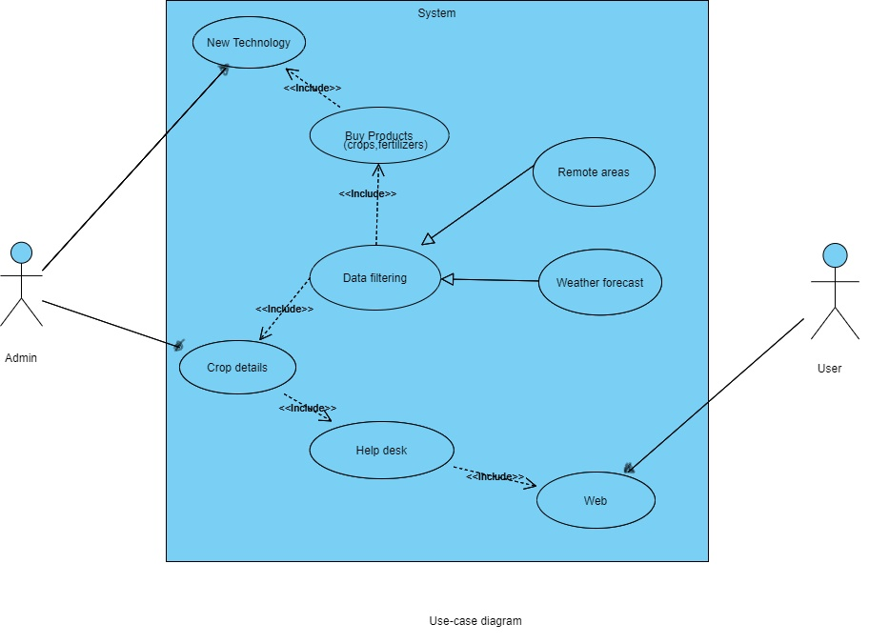

**CHAPTER 6: Conclusion, Future-Scope & References**

**6.1 Conclusion**

It is concluded that how internet based e-commerce will transform agribusiness is still indeterminate. Supply chains may become more efficient. Stronger connection between producers and consumers may result in more differentiated products that meet consumer needs. E-commerce offers an alternative venue of promoting and marketing agricultural products that has a benefit of reaching extensive geographical populations and providing detailed product information at a relatively low cost. Markets may become more transparent.

The system that promises to change the way farms and individuals purchase agricultural products by delegating tasks involved in buying and selling to intelligent mobile agents. Also this system promises to connect buyers and sellers in a ways that ensure the integrity and visibility of valuable products to consumers, while trading partners can share a wide range of communiqué and data. In this study, price comparison was the major focus. An effective E-commerce site, buyers experience must surpass the store experience such as price comparison (buyers want a fair price) and detailed product information. When implemented, the integrity, effectiveness and efficiency of trading in the agricultural industry is ensured. It stands a better chance of generating higher revenue for the government than E-commerce.

So, new internet-based technologies make a significant difference in the way

of connecting people, sharing information, negotiating prices and

payments, etc. In next couple of years, it is expected to have an expansion

of online trading, new providers and better integration of food producers.

**6.2 Future Scope**

In future, we will be converting this website into an app which would help farmers to buy goods and services in a more convenient way.

Scope of E-commerce is too wider in the near future because most of the people are using using online products and it will help farmers in trading , In future, agriculture products will be used too much from e commerce , so we can expect a huge market in e-commerce in near future in india. So, It offers a lucrative business opportunity by drawing significant revenue from affiliate sales . Finding the cheapest items it not the main purpose, detecting the best quality items for the least amount of money is the main challenge.

**6.3 References**

1. Gupta, U.G., 1999. Information Systems: Success in the 21st Century. Prentice Hall Publisher.
2. Priya Jashnani. (2015) Mobile and E-Commerce Grocery Retail and Food Service Bloom
3. Agribusiness sector in Rural India and increasing opportunities in e-Commerce. Marketing to Rural Consumers-Understanding and tapping rural market potential.
4. Mueller, R. (2000): Emergent E-Commerce in Agriculture, AIC Issues Brief, Ney York.
5. The Economics of Dot.coms and ECommerce in the Agrifood Sector, Review of Agricultural Economics, Vol. 25, No. 1
6. <https://pdfs.semanticscholar.org/deb9/a29179e356f23572b48a24a7466bc90753eb.pdf>
7. <https://www.researchgate.net/publication/329528325_Status_and_scope_of_e-commerce_in_agribusiness_in_India>
8. <https://youngagrarians.org/ecommerce-farmers/>
9. <https://www.spinxdigital.com/blog/common-web-design-languages-what-they-do-and-why-you-need-them/>
10. <https://www.dbmanagers.com/agriculture-website-farmers-website-design/>

|  |  |
| --- | --- |
|  |  |
|  |  |